VeeLuame Multi-screen Splicing Intelligent Display System
Quick Guide

- This guide only provides users with simple operating instructions;
- Please refer to the instruction manual for details.(Official website or consult customer service)
Product Name: VeeLuame Multi-screen Splicing Intelligent Display System
Product model: H5
- Unpack and check
Check the contents of the package: screen splicing controller, TV screen, power cable, power adapter, manual, accessories (such as remote control, HDMI cable, network cable, installation tools, etc.).
Inspection: Carefully inspect the appearance of the product for damage.
- Quick installation
Hardware Installation:
- Take out the vertical bar and square tube horizontal bar in the package, and assemble it into a wall bracket as shown in the following figure with screws;
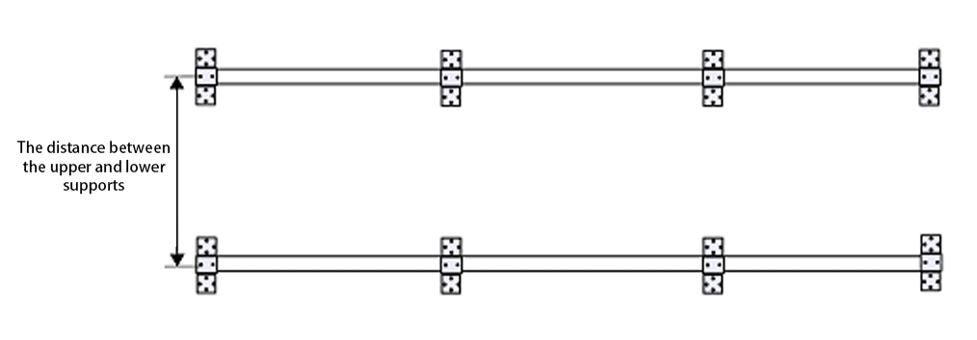
Figure 2-1 Schematic diagram of bracket assembly
- Fix the wall bracket to the predetermined wall surface with expansion bolts;
- Use the hook to hang the TV screen on the splicing wall bracket in turn.
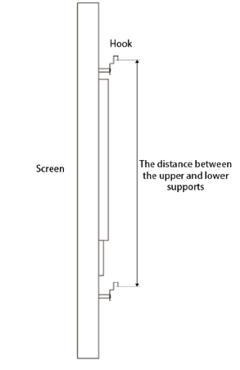
Figure 2-2 Screen hook diagram
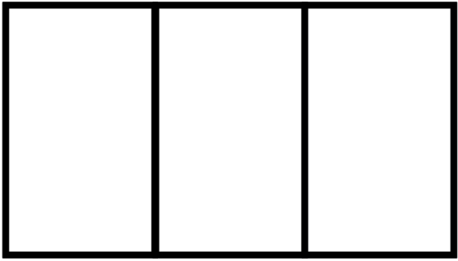
Figure 2-3 Screen splicing diagram

Device Connections:
- Connect the HDMI IN interface of the TV screen to the HDMI OUT interface of the screen splicing controller through the HDMI cable;
- Plug in the power cord on the TV screen;
- Plug in the power adapter on the screen walling controller.
- Basic debugging on the PC side
  - Connect before PC debugging:
- Use a network cable to connect the router to the screen splicing controller;
- The computer is also connected to the network of the above router;
- After the power is turned on, the TV screen displays the IP of the device;
- Enter the device IP address in the address bar of the browser to enter the debugging page.
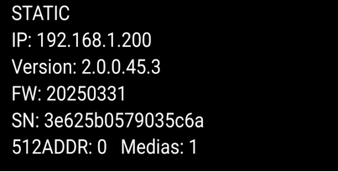
Figure 3-1 Power-on display
  - Display settings
After entering the web login page, the administrator login page appears, the initial administrator account is: admin The initial administrator password is: public After logging in, you can enter the device display management interface as shown in Figure 3-2 below.
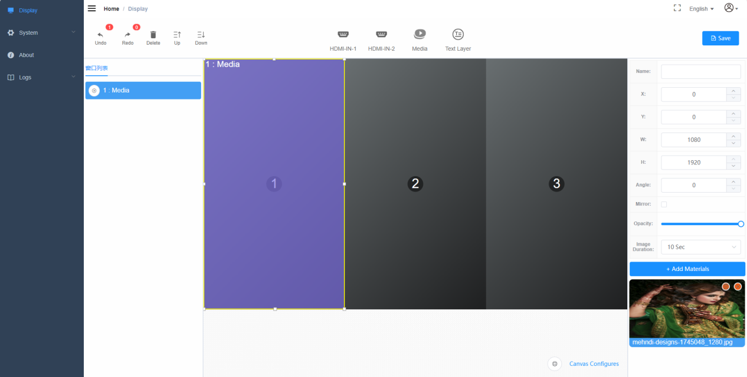
Figure 3-2 Display settings
It is recommended to change the username and password after the initial login. In the upper right corner of the home page, you can change your password and log out, as shown in Figure 3-3 below.
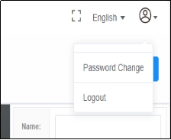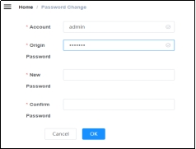
public
Figure 3-3 Changing the log-in password
- Display settings - screen layout settings: select the screen direction, splicing specifications and display angle according to the actual installation effect;
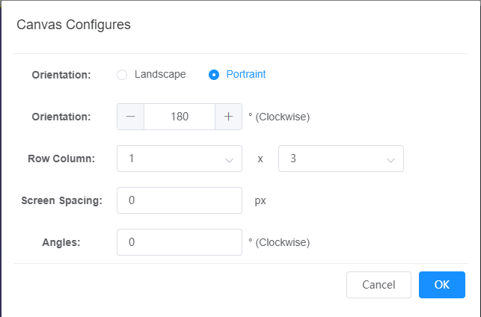
Figure 3-4 Screen layout settings
- Display Settings - Window List: Displays the added windows, the display priority is reduced from top to bottom, and after the windows are superimposed, you can move up, move down, delete, restore, and undo operations.
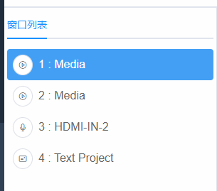
Figure 3-5 Window list
- Display settings - different types of window settings: There are not many types of windows that can be opened on the device. HDMI IN 1, HDMI IN 2, these windows can be connected to an external computer input signal. Multimedia players are windows that can play different materials, such as video files and pictures. The text window can display the text text.
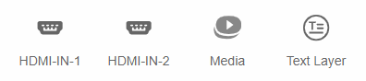
Figure 3-6 Window settings
- Display Settings - Window Properties: Each window has its own properties. The basic information includes the horizontal and longitudinal coordinates of the window, the size (width and height) of the window, the angle of the window, the mirror image of the window, and the transparency of the window.
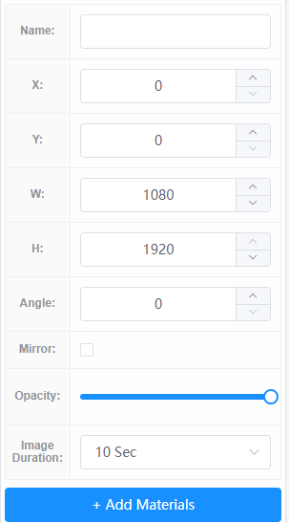
Figure 3-7 Window properties
- Display Settings - Add Materials: You can upload videos, pictures and other materials from your computer to your device. By default, there are 255 folders in the device. Each folder can be renamed. After the footage is uploaded, you can view the number of uploaded items, preview the footage, or delete it. Select the footage and add it to the playlist on the right side of the corresponding player.
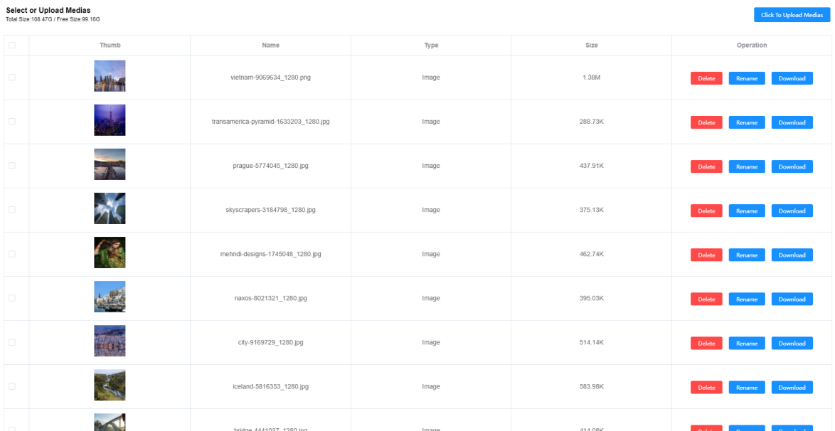
Figure 3-8 Adding materials
  - Network settings
The device supports two methods: automatically obtaining IP addresses or manually modifying IP addresses. By default, the system is automatically obtained, and when the device is connected to the network in this way, the device can be used when it is connected to the router. If you want to network with a static IP address, you can select a fixed IP address to manually set it. To manually set the IP, you need to enter the IP, subnet mask, gateway, and DNS.
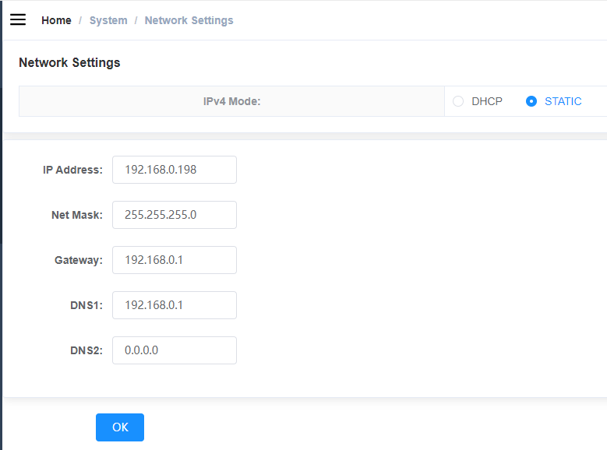
Figure 3-9 Network settings
  - Video settings
When playing a video, you can turn the audio on or off, and the system is off by default. The volume of the system can be adjusted, and the default is the maximum. When the system is working, you can click on the screenshot to send the screen back to the device.
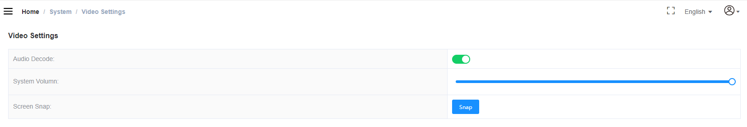
Figure 3-10 Video settings
  - Device version information
Device version information includes software version information, system firmware information, hardware PCB information, device SN number, and MAC address.
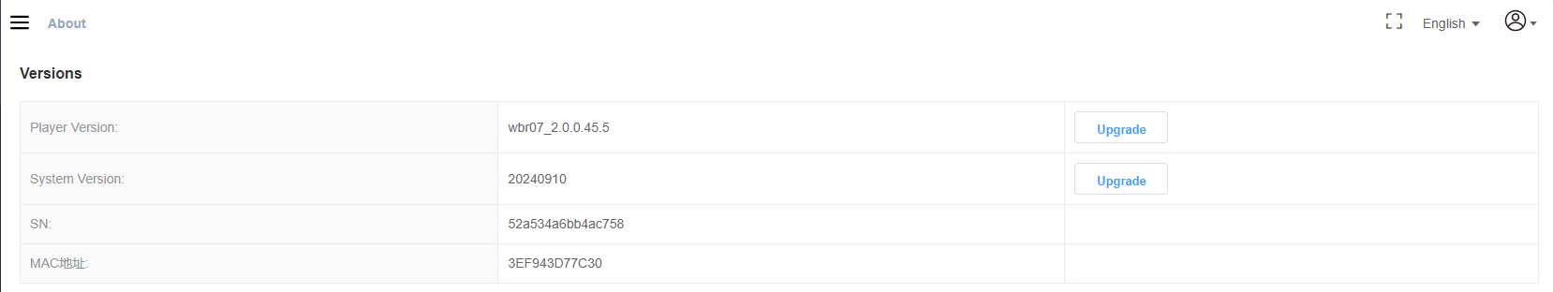
Figure 3-11 Device version information
  - Device logs
After the device is powered on, important information is recorded. You can download the system log or playback log and view the running status of the device. Logs can be deleted.
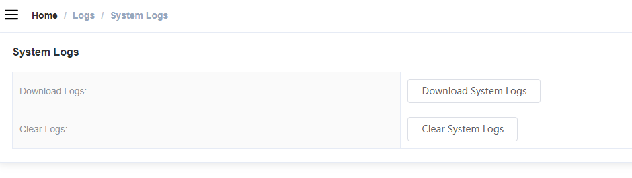
Figure 3-12 Device logs
- Basic debugging on the mobile phone
  - Connect to the mobile phone before debugging
- Use a network cable to connect the router to the screen splicing controller;
- The mobile phone is connected to the network WiFi under the same router;
- Go to the software for debugging.
  - Basic operations
- After entering the mobile software VeeControl, the following interface will be displayed, and the saved programs will appear in the program list, which can be modified, deleted and sent to the device.
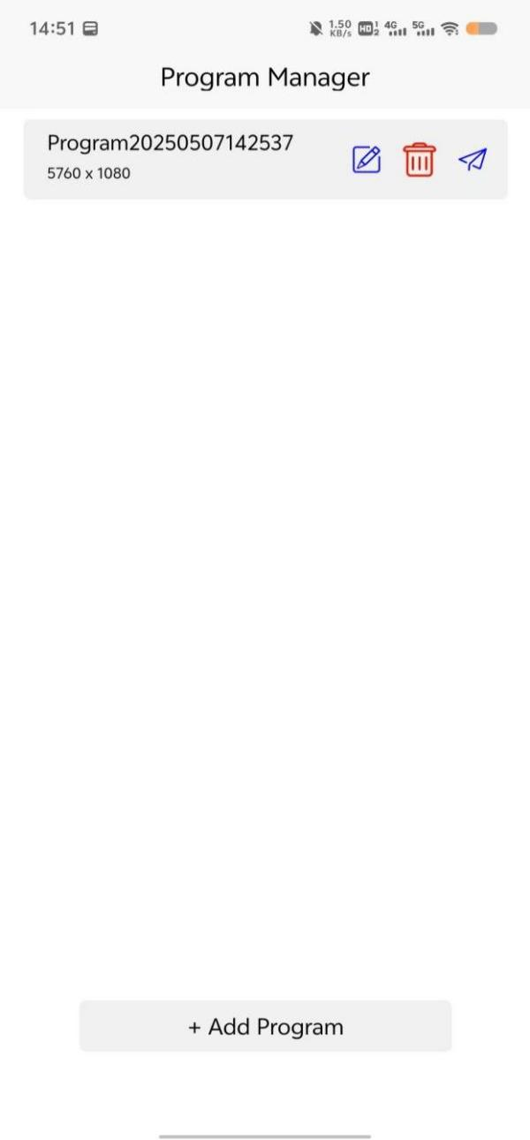
Figure 4-1 VeeControl on the mobile phone
- Click "+ Add a program" below, the screen layout settings appear, you can choose
the screen direction (horizontal screen or vertical screen), the number of screens is the arrangement, such as two screen splicing, then select 1×2 or 2×1, and a screen example will appear below after selection. The name of the program can be changed in the upper right corner.
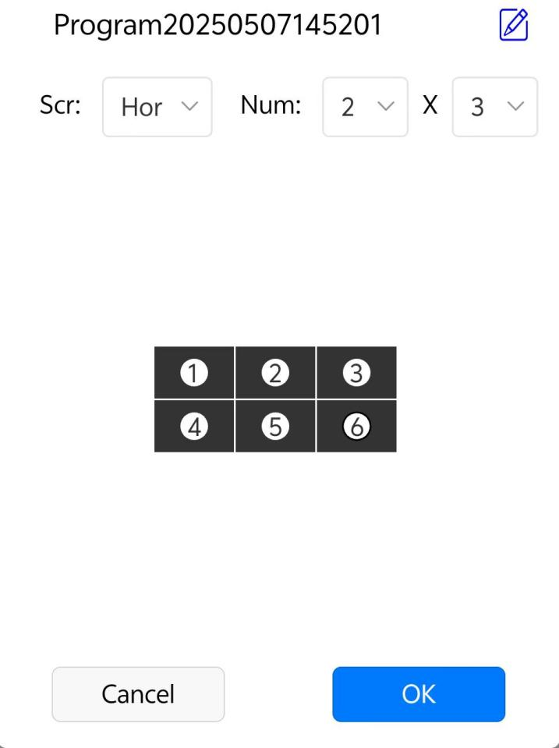
Figure 4-2 Adding a program
- Media window
Users can change the corresponding attributes according to their actual needs. Window X represents the transverse coordinates, and window Y represents the longitudinal coordinates. Window W represents the width of the window, and window H represents the height of the window. Click "Video" to add a video file. Click "Image" to add an image file.
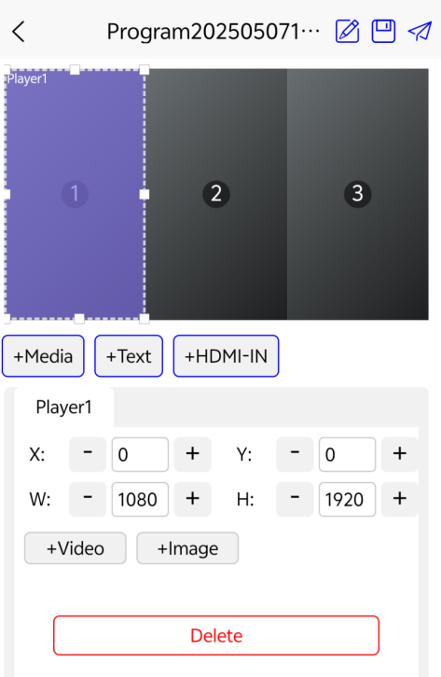
Figure 4-3 Media window settings
- Text window editing management
After the text window is created, fill in the text information required by the user in the text "Please enter text" prompt box, or click the delete button to clear all the current text messages.
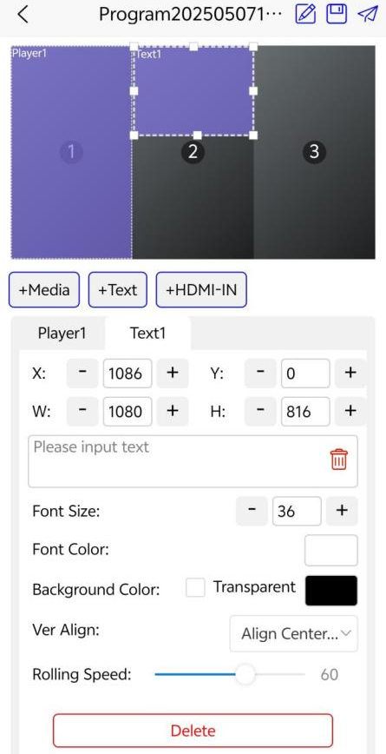
Figure 4-4 Text window settings
- HDMIIN window editing management
Once the HDMI IN window is created, you can set different properties "Angle" to set the rotation angle of the picture, from 0 degrees to 360 degrees. Transparency sets the transparency of the current window. Fillet sets the four corners of the current window to arc.
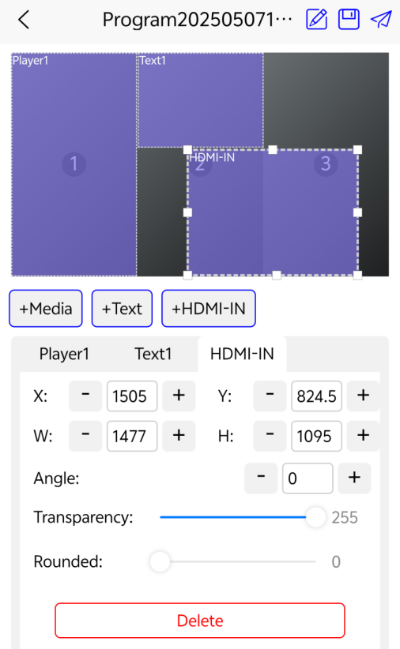
Figure 4-5 HDMI-IN window settings
- Once you are done designing your window, you have to click the Save button in the upper right corner.
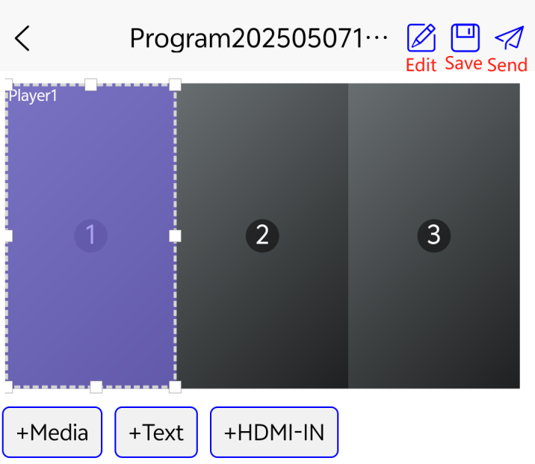
Figure 4-6
- After saving, click Send in the upper right corner to enter the program release page, and click to log in (initial account: admin, password: public)
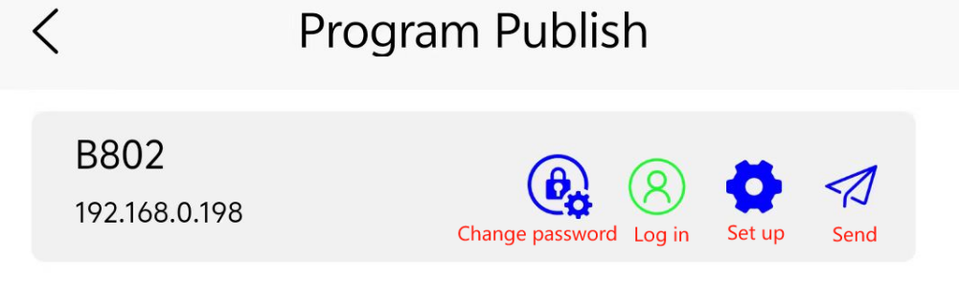
Figure 4-7 Program release
- If it is the first time to use, you can click the “Set up” in Figure 4-7 to modify the device name for the next search.

- Safety Precautions
This system has been strictly debugged before leaving the factory, but incorrect use may cause electric shock and fire. To ensure safety, extend the service life of this system, and give full play to the best performance of this system, please read the following regulations carefully before using the system and strictly abide by the safety precautions.
- Around the TV screen to ensure proper ventilation; do not cover the vents with items such as newspapers, tablecloths, and curtains that may obstruct ventilation.
- Do not place it outdoors and avoid direct sunlight, rain and wind.
- Before installing the wall mount, you must check the load-bearing reliability of the installation wall surface.
- When unplugging the power cord, do not just hold the cord.
- Do not place heat or naked flame sources, such as lighted candles or night-lights, on or near the unit.
- If the power cord is found to be damaged, do not continue to use it.
- To protect the environment, used batteries should be disposed of according to the recycling methods implemented in the area.
- Do not use in humid, high temperature or flammable environments .
- Children should use interactive features under adult supervision

- Common troubleshooting
fault | Solution
Won't turn on | Check whether the power supply is plugged into the interface;  whether the power supply of the socket is normal;
Unable to enter the PC debugging interface | Check if the IP address is correct;  Whether the computer and the screen wall controller are in the same domain;  whether the computer network connection is normal;
Unable to enter the debugging interface on the mobile phone | Check if your phone is in the same domain as the screen splicing controller;
- Get help
Official support:http://www.veeluame.com/
Customer service number: 86-86933020
Contact email: admin@veeluame.com
Warranty: The warranty period of the whole system is one year

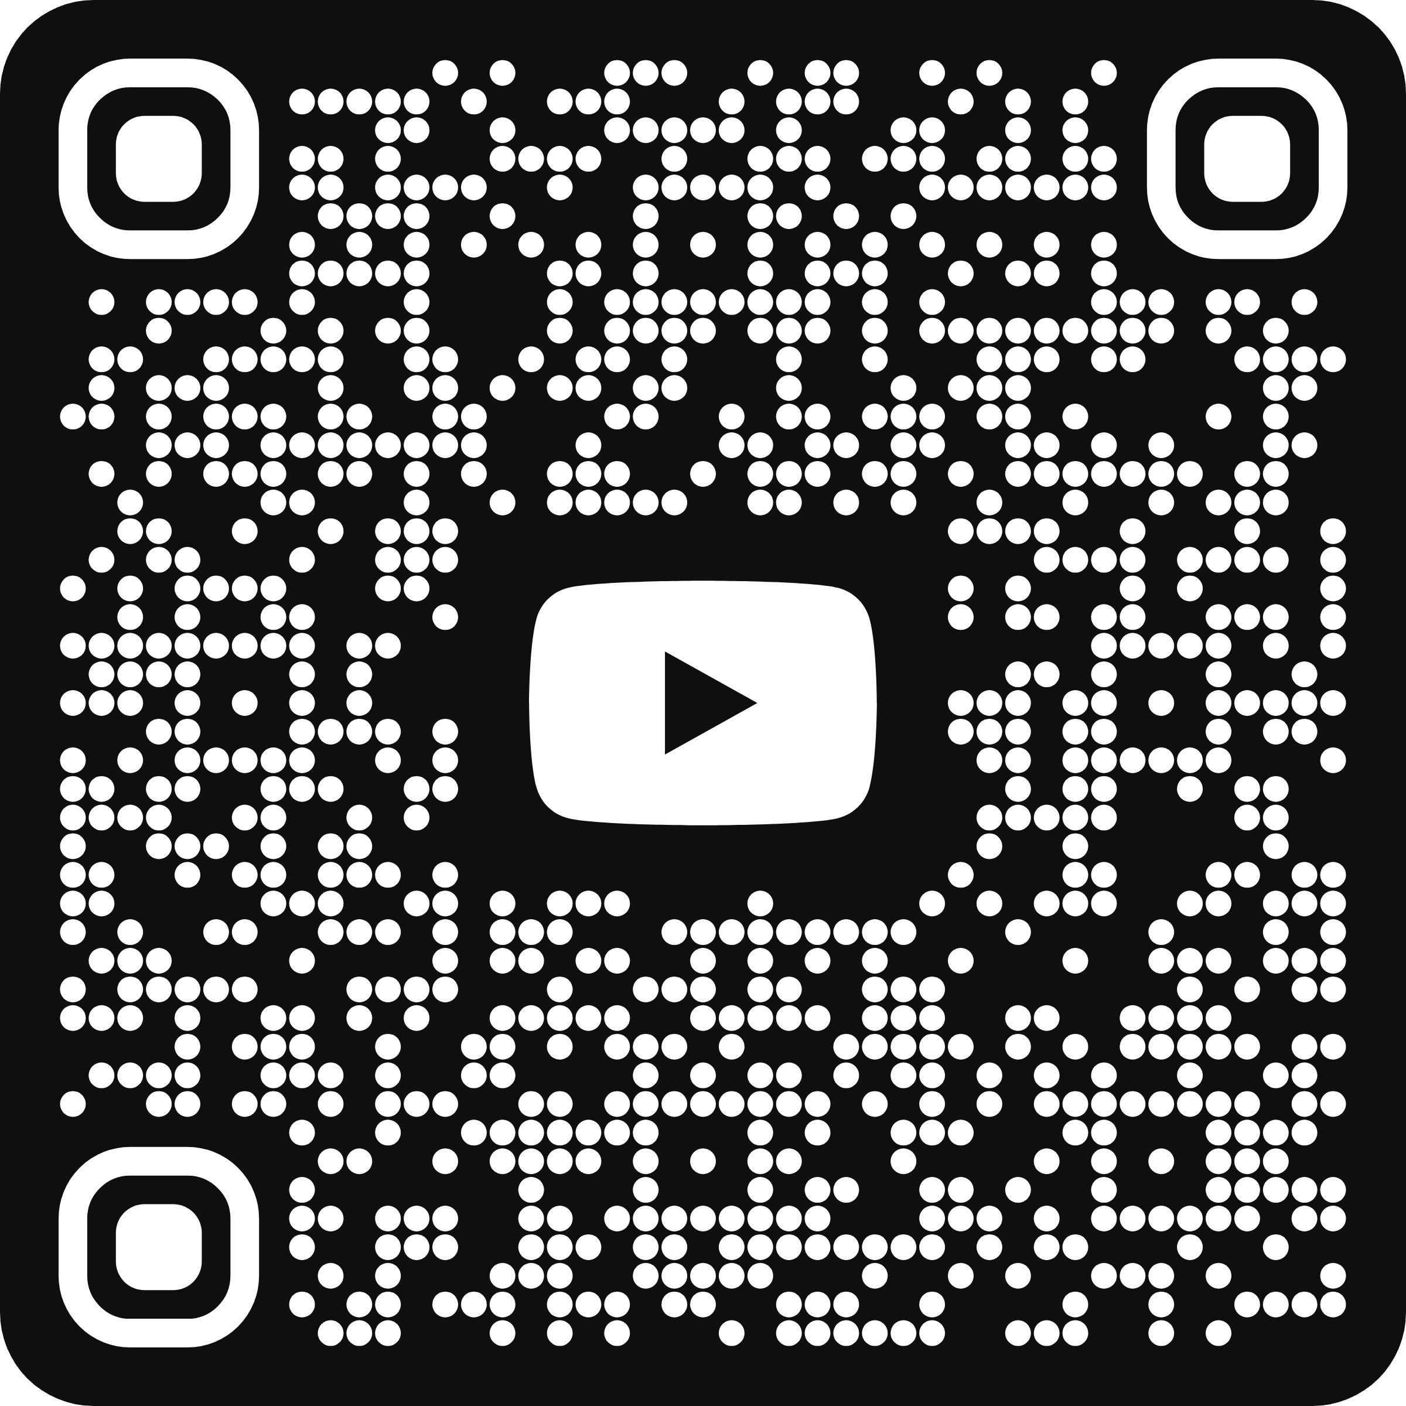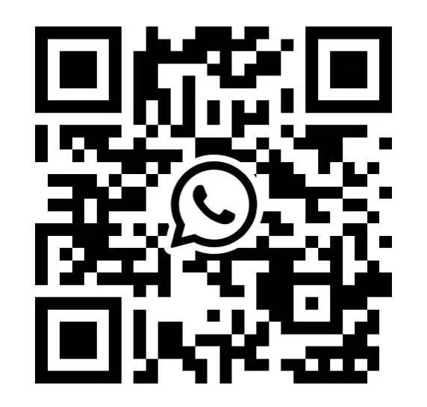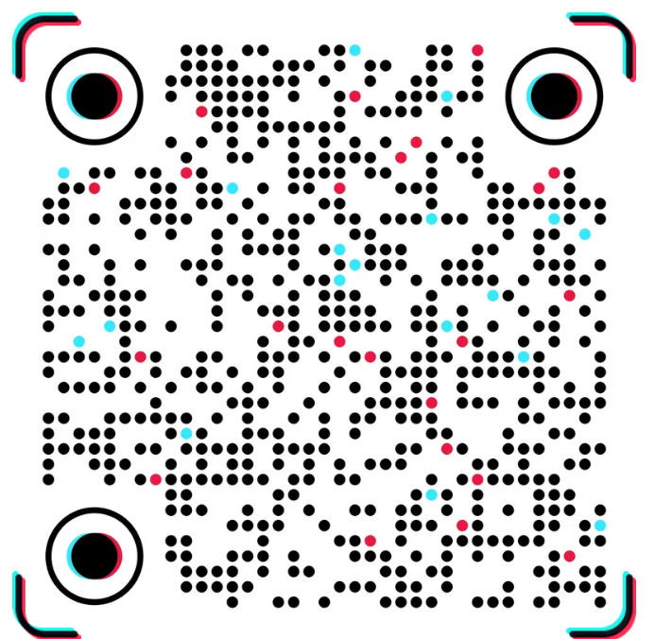
Tik Tok
Ai vision
「Original materials」
WhatsApp
Youtube

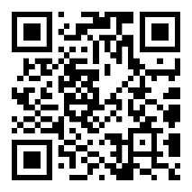

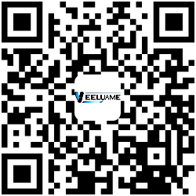
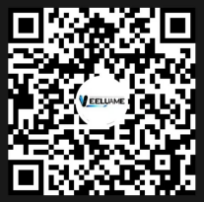
Website
DouYin
Tou Tiao
WeChat Channel

Tip: Please refer to the full manual for detailed operation

