VeeLuame Multi-screen Splicing Intelligent Display System
User Manual

File status:  [ ] Under revision  [√] Official release | Current version: | V3.1
File status:  [ ] Under revision  [√] Official release | Author: | Gina
File status:  [ ] Under revision  [√] Official release | Target date: | 2025.5.7
File status:  [ ] Under revision  [√] Official release | Examine and verify:
File status:  [ ] Under revision  [√] Official release | Target date:

- Please read this instruction manual carefully before using the product
- Please keep this manual properly
Version number | Modifier | Date changed | Instructions
V1.0 | Gina | 2025.4.18 | First draft
V2.0 | Gina | 2025.4.21 | Add a schematic diagram of the controller, version description, header and footer
V3.0 | Gina | 2025.4.21 | Add the schematic diagram of the bracket and screen hook, and modify the image number and page number
V3.1 | Gina | 2025.5.7 | Modify the image number and page number
Version history
VeeLuameMulti-screen splicing intelligent display system user manual
1. Product composition 4
1.1. Main Components 4
1.2. Main accessories 4
2. Product advantages and disadvantages 5
2.1. Comparison with LCD splicing screens in the same industry 5
2.2. Compared with LED splicing screen 5
3. Installation Steps 6
3.1. Hardware Installation 6
3.1.1. Bracket fixation 6
3.1.2. Screen splicing installation 6
3.1.3. Controller Connection 8
3.2. Software Connection 8
3.2.1. PC login 8
3.2.2. Mobile phone connection 11
4. PC software operation guide 11
4.1. Basic Function Introduction 11
4.1.1. Display Settings 11
4.1.2. Network Settings 15
4.1.3. Video Settings 15
4.1.4. Device version information 16
4.1.5. Device logs 16
4.2. Screen splicing and splitting operation guide 17
4.2.1. Single screen display and split screen 17
4.2.2. Dual screen display and splicing 18
4.2.3. HDMI IN screen projection function 19

5. Mobile software operation guide 20
5.1. Basic Function Introduction 20
5.1.1. Initial interface 20
5.1.2. New programs 20
5.1.3. Media window editing and management 21
5.1.4. Text window editing management 22
5.1.5. HDMIIN window editing and management 23
5.2. Screen splicing and splitting operation guide 25
5.2.1. Debug interface 25
5.2.2. Screen settings 25
5.2.3. Saving 26
5.2.4. Log in 26
5.2.5. set up 26
5.2.6. Sending 27
6. Maintenance and Security 27
6.1. Precautions 28
6.2. Daily maintenance 29
7. Troubleshooting 29
8. Technical Support 30
Appendix: VeeControl controller interface diagram .............................................31

Vee Luame Multi-screen Splicing Intelligent Display System User Manual
VeeLuame multi-screen splicing intelligent display system adopts an LCD high-definition screen with an ultra-narrow bezel design, supports multi-screen splicing, and is suitable for monitoring centers, conference rooms, home viewing, home entertainment, exhibition halls, KTV, advertising and other scenarios. It can realize multi-screen image synchronization control, support signal source switching, screen splitting and other functions, and has flexible installation methods. It can be controlled and adjusted on both the PC and mobile phone sides, perfectly meeting commercial needs.
- Product composition
  - Main Components
- Display device: high-definition LCD display (the quantity depends on the splicing scale)
- VeeControl splicing controller: realize multi-screen synchronization and seamless splicing
- Bracket structure: Professional wall bracket assembly
  - Main accessories
- A power adapter
- One network cable
- One HDMI high-definition cable
- A remote control
- Product advantages and disadvantages
  - Comparison with LCD splicing screens in the same industry
project | VeeLuame multi-screen splicing intelligent display system | Other splicing display systems
control | Mobile phone control + PC control | PC side control
material | High-definition footage available | Not available
Screen | Waterproof design | No waterproof
Serve | Hardware and software integration services | Screen and controller sold separately
  - Compared with LED splicing screen
project | LCD screen | LED screen
radiation | Low | high
price | Low | high
Installation and transportation | convenient | complex
Energy consumption | Low | high
Clarity | high | Low
Color reproduction | high | Low
Close viewing effect | Clarity | Vague
Is it explosion-proof? | yes | no
Whether there is a stitching seam | have | none
Is it suitable for outdoor use? | no | yes
- Installation Steps
  - Hardware Installation
    - Bracket fixation
Take out the vertical bar bracket (4pcs) and square tube horizontal bar (2pcs) from the customized wall bracket package of the splicing screen, and use screws to fix the square tube horizontal bar on the vertical bar bracket to assemble the splicing wall bracket assembly as shown in Figure 2-1. Then use expansion screws to fix the splicing bracket on the wall or cabinet. The fixing height is determined according to actual needs to ensure levelness.
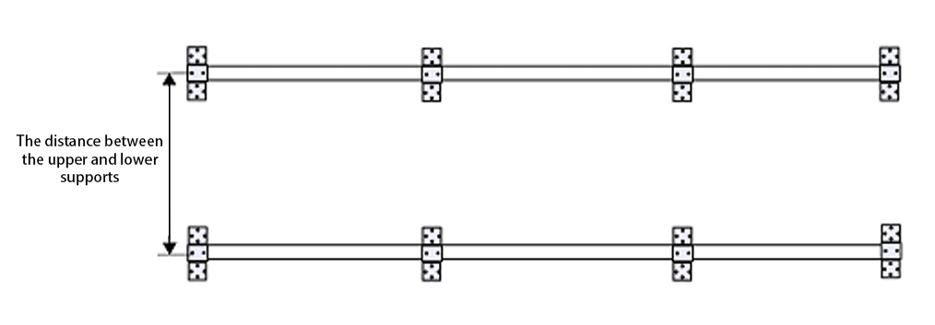
Figure 2-1 Schematic diagram of bracket assembly
    - Screen splicing installation
Take out the hooks from the wall mount accessory package, and fix them to the holes on the back of the spliced screen with screws, as shown in Figure 2-2. Then, hang the LCD screens on the brackets one by one, and adjust the gaps to be even , as shown in Figure 2-3.
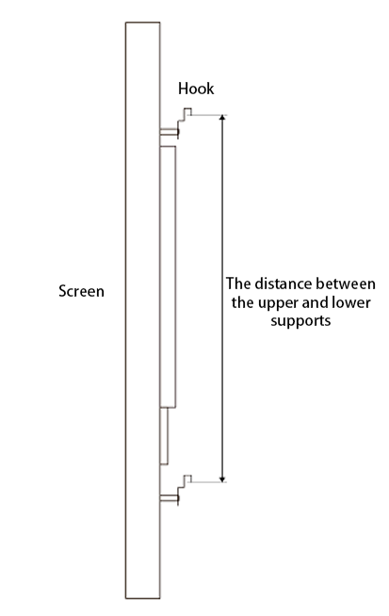
Figure 2-2 Screen hook diagram
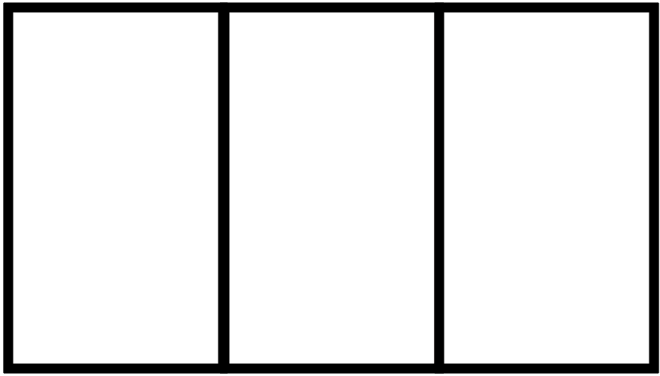
Figure 2-3 Screen splicing diagram
    - Controller Connection
Connect the HDMI high-definition cable to the controller output interface (HDMI OUT 1, HDMI OUT2, etc.) and the corresponding screen input interface HDMI IN . Connect the HDMI IN of the first screen to the HDMI OUT1 of the controller; connect the HDMI IN of the second screen to the HDMI OUT2 of the controller, and so on...
  - Software Connection
    - PC login
Method 1: Connect via a router
- Use an Ethernet cable to connect the LAN interface of the controller to the LAN interface of the router;
- The computer is also connected to the network of the above router;
- Turn on the power of each device and record the IP address displayed on the screen in Figure 2-4;
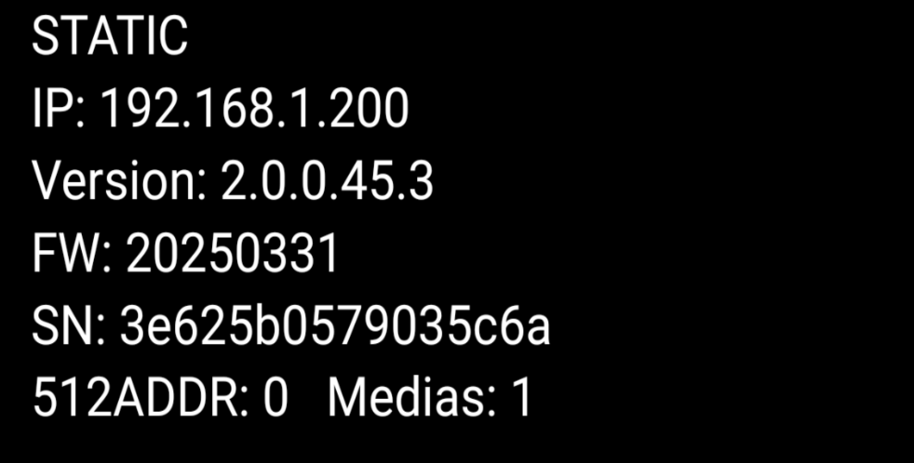
Figure 2-4 Power-on display
- Enter the above IP address in the address bar of the computer browser to enter the PC debugging interface, as shown in Figure 2-5 below. For specific debugging operations, see 4. PC Software Operation Guide.
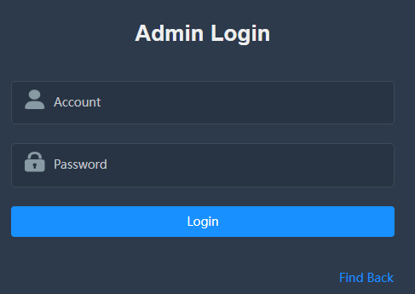
Figure 2-5 Administrator login
Method 2: Directly connect via network cable
- Use an Ethernet cable to connect the controller's LAN port to the computer's LAN port (a USB to Ethernet converter may be required);
- Manually set IP through computer (need to enter IP, subnet mask, gateway and DNS);
- Enter the manually set controller IP address in the computer browser address bar to enter the PC debugging interface. For specific debugging operations, see 4. PC software operation guide.

    - Mobile phone connection
- Use an Ethernet cable to connect the LAN interface of the controller to the LAN interface of the router;
- Make sure your phone and controller are connected to the same network;
- Install Vee Control, the mobile controller debugging software;
- Just add the screen layout in the software, see 5. Mobile software operation guide for details.
- PC software operation guide
  - Basic Function Introduction
    - Display Settings
After entering the web login page, the administrator login interface appears. The initial administrator account is: admin and the initial administrator password is: public. After logging in, enter the device display management interface shown in Figure 4-1 below.
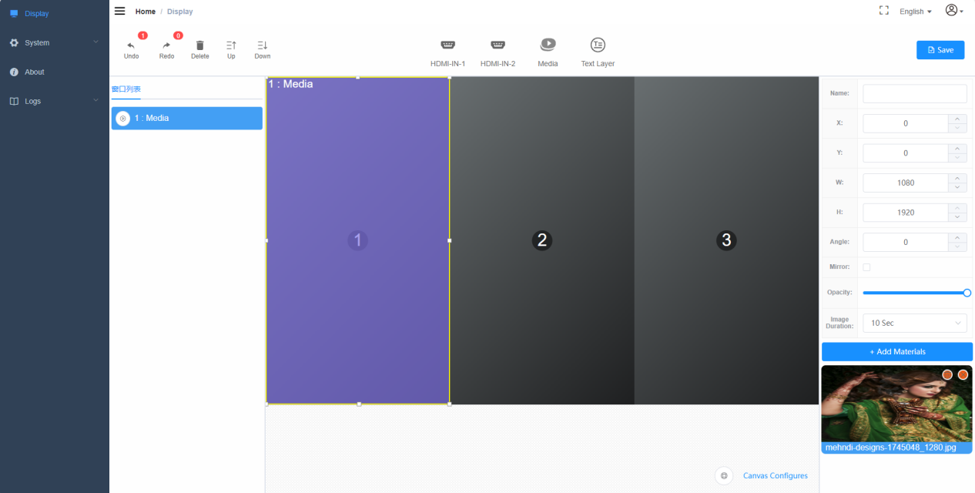
Figure 4-1 Display Settings
It is recommended to change the user name and password after the first login. You can change the password, log out, etc. in the upper right corner of the home page display settings interface, as shown in Figure 4-2 below.
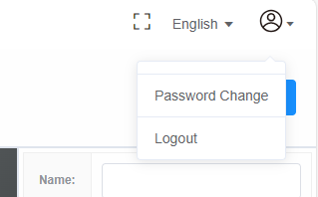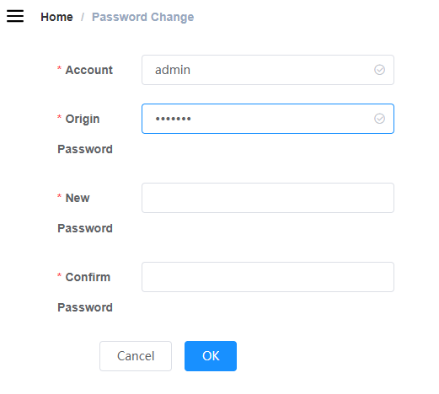
public
Figure 4-2 Modify log-in password
- Display settings - screen layout settings: select screen direction, splicing specifications and display angle according to the actual installation effect;
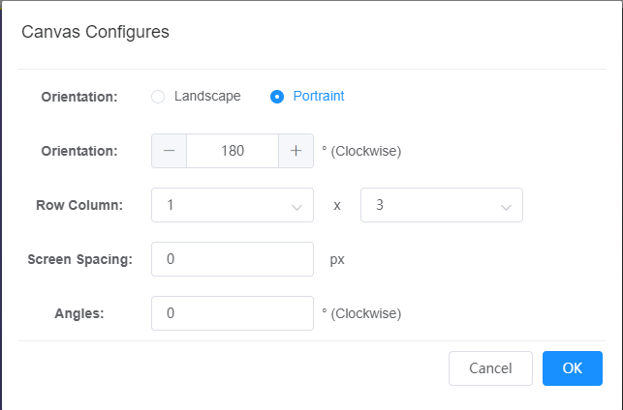
Figure 4-3 Screen layout settings
- Display Settings - Window List: Displays the added player window, text window and input window. Multiple windows can be superimposed on each other. The order represents the display priority, and the priority decreases from top to bottom. After superposition, each window can be moved up, down, deleted, restored or undone.
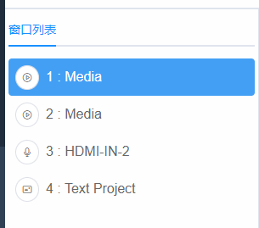
Figure 4-4 Window List
- Display settings - different types of window settings: The device can open a few window types. HDMI IN 1, HDMI IN 2, these windows can connect to external computer input signals. Multimedia player, these windows can play different materials, such as video files, pictures. Text on the wall, these windows can display text.
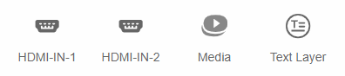
Figure 4-5 Window Settings
- Display Settings - Window Properties: Each window has its own properties. Basic information includes the direction of the window, the size of the window (width, height), the angle of the window, the mirror image of the window, and the transparency of the window.
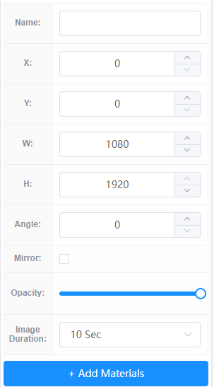
Figure 4-6 Window Properties
- Display Settings - Add Materials: You can upload videos, pictures and other materials from your computer to the device. There are 255 material folders in the device by default. Each material folder can be renamed. After uploading the material, you can check the number of uploaded materials, preview the material, and delete it. Select the material and add it to the playlist on the right side of the corresponding player. You can drag the material to adjust the play order.
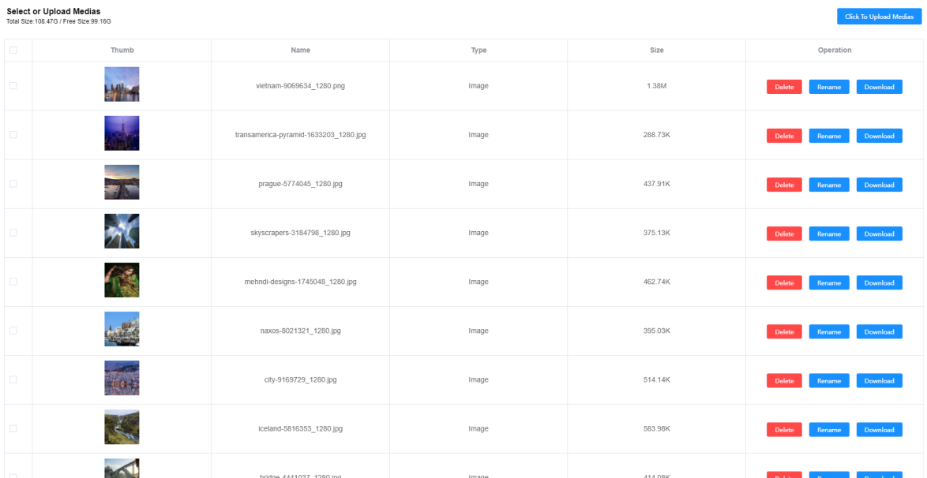
Figure 4-7 Adding materials
    - Network Settings
The device supports two methods: automatic IP acquisition and manual IP modification. The system defaults to automatic acquisition. When connecting to the network in this way, the device can be used by connecting to the router. When the user needs a static IP network, you can choose a fixed IP to set it manually. To set the IP manually, you need to enter the IP, subnet mask, gateway, and DNS.
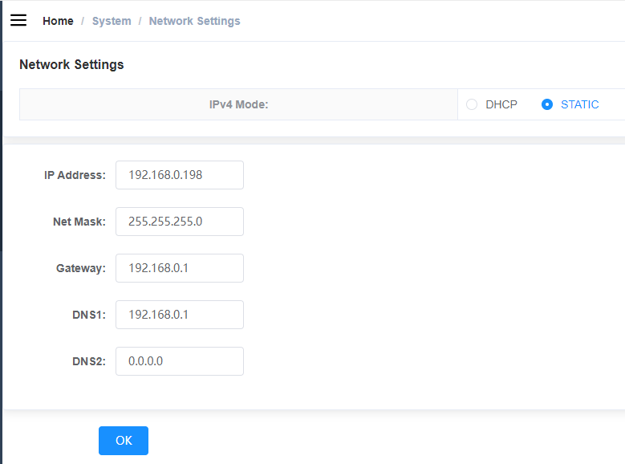
Figure 4-8 Network Settings

    - Video Settings
The audio of the video being played can be turned on or off, and the system defaults to off. The volume of the system can be adjusted, and the default is maximum. When the system is working, you can click on the screen to take a screenshot and send the screen back to the device.
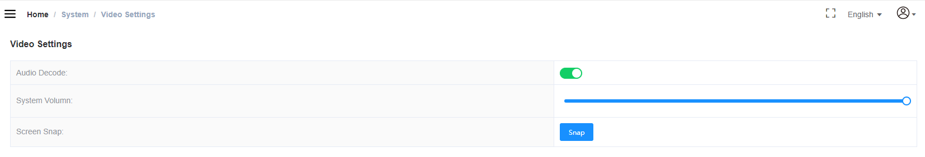
Figure 4-9 Video Settings
    - Device version information
Device version information includes software version information, system firmware information, hardware PCB information, device SN number, and MAC address.
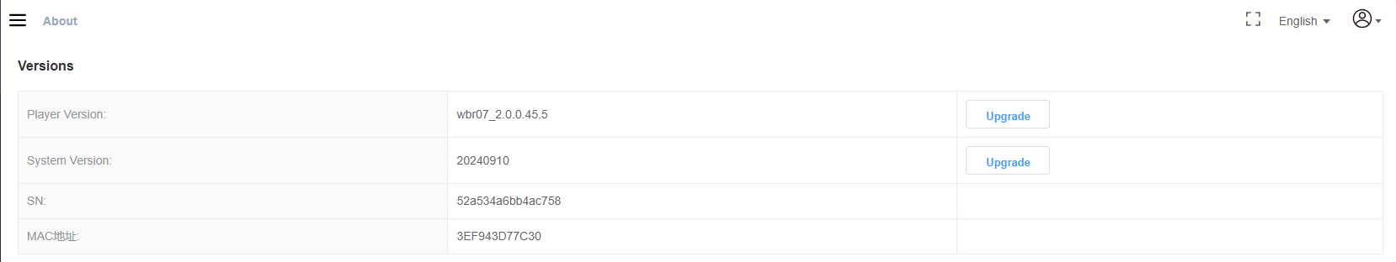
Figure 4-10 Device version information
    - Device logs
After the device is powered on, the system will record important information. You can download the system log or playback log to view the device's operating status. The log can be deleted.
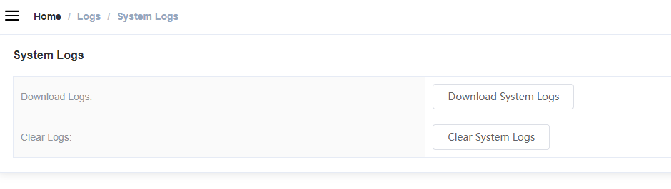
Figure 4-11 Device log
  - Screen splicing and splitting operation guide
Supplemental introduction:
- Angle adjustment: When using for the first time, you can observe the angle of the content displayed on the TV screen when the screen layout rotation angle is 0, and then reset the screen angle
- This note only shows the splicing of dual screens. For screen splicing displays of three or more screens, adjust the row and column layout according to actual requirements and then proceed with subsequent operations.
    - Single screen display and split screen
- In the screen layout setting, select horizontal or vertical screen, select 1×1 for row and column layout, and rotate the angle according to actual needs;
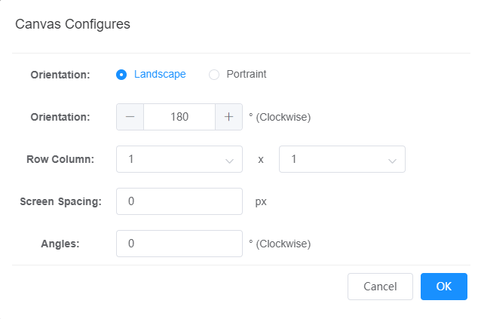
Figure 4-12 Single screen layout
- Drag and drop multimedia players, HDMI IN, and text windows to the corresponding screens as needed;
- The screen can be split by modifying the horizontal and vertical coordinates, width and height of the window on the right side of the page. You can also use the mouse to stretch or shrink the window.
- Select the corresponding window to add materials, enter text, etc.;
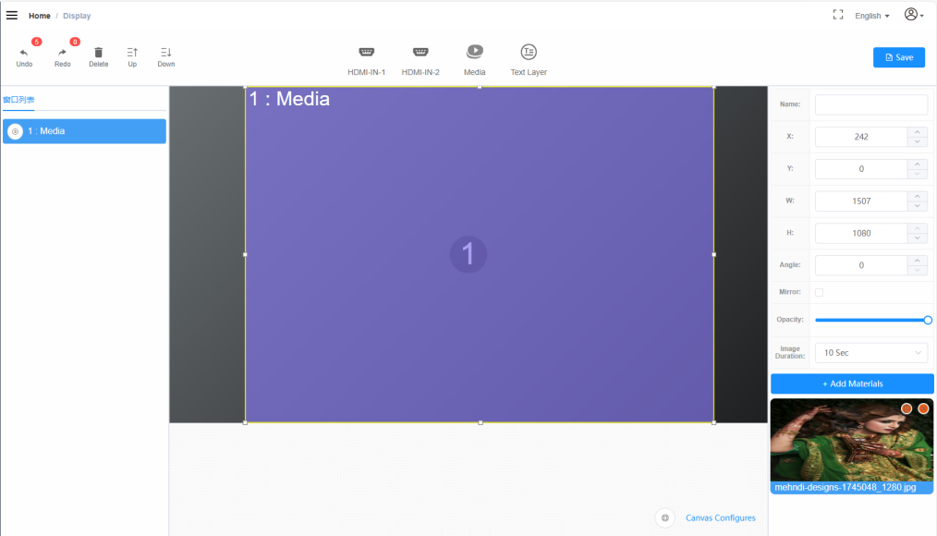
Figure 4-13 Single-screen debugging interface
    - Dual screen display and splicing
- In the screen layout setting, select horizontal or vertical screen according to needs, select 1×2 or 2×1 for row and column layout, and rotate the angle according to the actual display effect;
- Drag and drop multimedia players, HDMI IN, and text windows to the corresponding screens as needed;
- By adjusting the window size to cover both screens, two screens can be spliced together;
- You can also adjust the window size or overlay multiple windows as needed.
- Select the corresponding window to add materials, enter text, etc.;
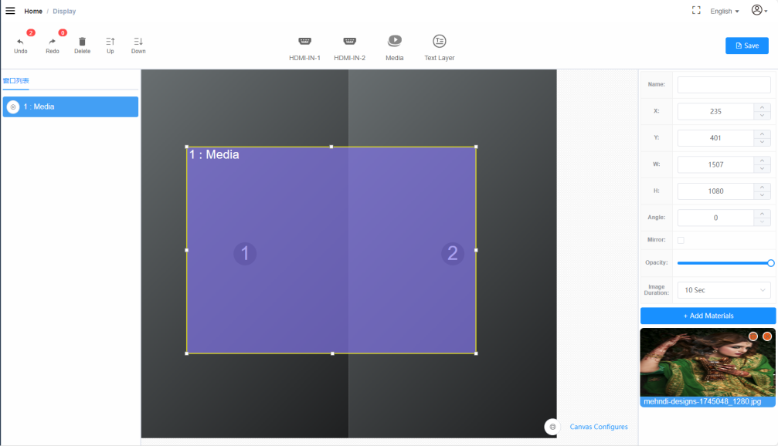
Figure 4-14 Dual-screen debugging interface
    - HDMI IN screen projection function
- Use an HDMI cable to connect your computer to the HDMI IN port of the controller (or use an HDMI wireless transmitter);
- Set the screen projection mode on the computer; (such as copy, extend, computer screen only, second screen only)
- Open the content you want to project, such as PPT, spreadsheets, documents, videos, and pictures;
- After the projection content is displayed normally on the splicing screen, you can use the mouse to operate it.

- Mobile software operation guide
  - Basic Function Introduction
    - Initial interface
After entering the mobile software VeeControl, the following interface is displayed. All saved programs will appear in the program list, and the programs can be modified, deleted, and sent to the device.
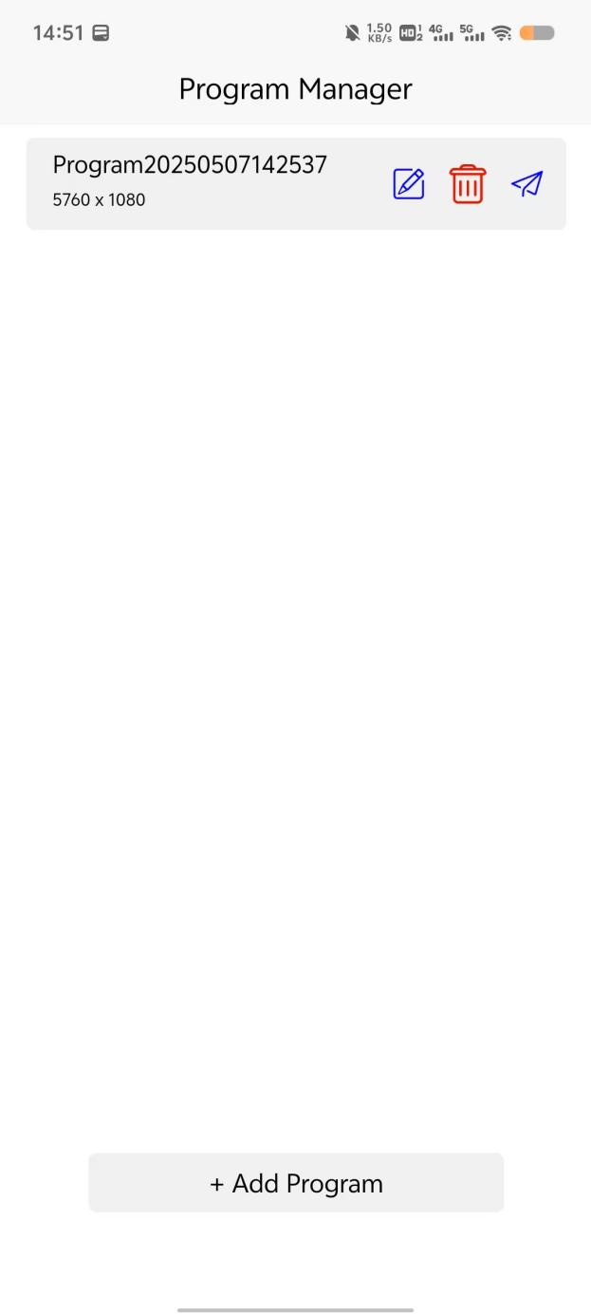
Figure 5-1 VeeControl on mobile phone
    - New programs
Click "+ Add Program" below, and the screen layout settings will appear. You can select the screen direction (horizontal or vertical), the number of screens, or the arrangement method. If two screens are spliced, select 1×2 or 2×1. After selection, a screen example will appear below. You can change the program name in the upper right corner.
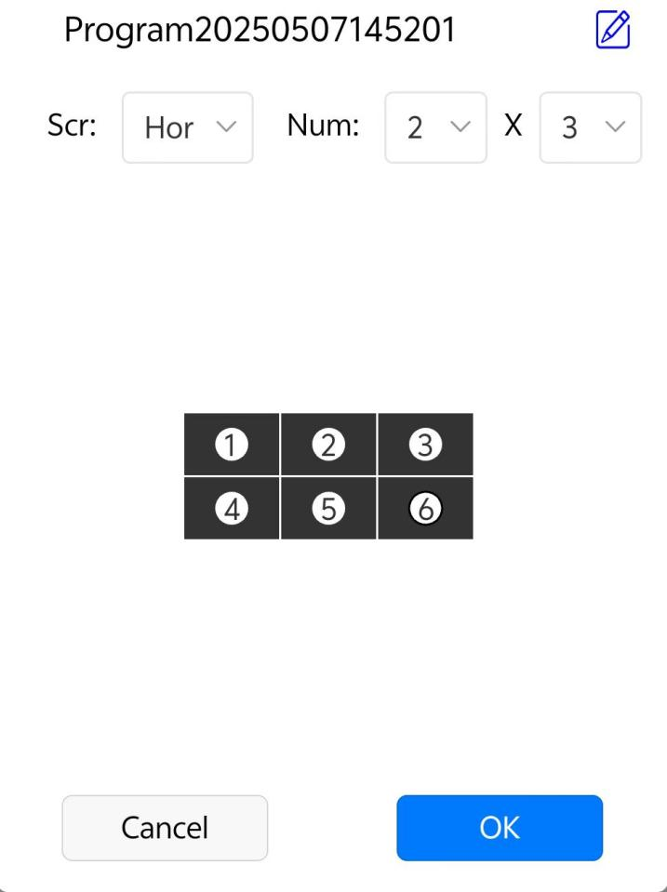
Figure 5-2 Add a new program
    - Media window editing and management
Users can change the corresponding properties according to actual needs. Window X represents the horizontal coordinate, and Window Y represents the vertical coordinate. Window W represents the width of the window, and Window H represents the height of the window. Click "Video" to add video files. Click "Picture" to add picture files. Click "Delete" to delete the current media window. After editing the media window, click "Save" in the upper right corner to save the currently edited properties.
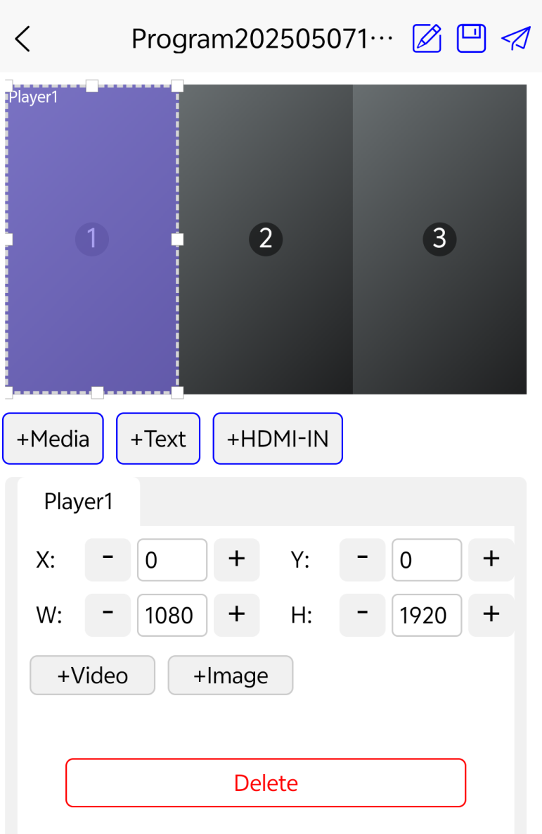
Figure 5-3 Media window settings
    - Text window editing management
After the text window is created, fill in the text information the user needs in the text "Please enter text" prompt box, or click the delete button to clear all current text information. Text window X represents the horizontal coordinate, text window Y represents the vertical coordinate, text window W represents the width of the window, and text window H represents the height of the window. "Text size" can adjust the size of the text. "Text color" can set different colors for the text. "Background color" can set the background display color of the text. "Vertical alignment" can allow the text to be aligned in different ways. "Scroll speed" can set the speed at which the text scrolls from right to left. "Delete" can clear the current text window.
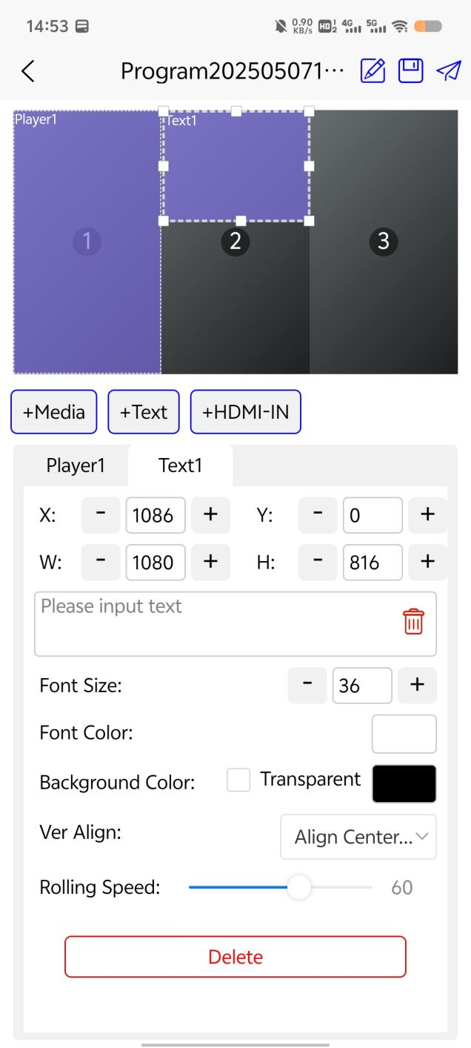
Figure 5-4 Text window settings
    - HDMI - IN window editing and management
After the HDMI IN window is created, different properties can be set. Window X represents the horizontal coordinate, Window Y represents the vertical coordinate, Window W represents the width of the window, and Window H represents the height of the window. "Angle" can set the rotation angle of the screen from 0 to 360 degrees. "Transparency" can set the transparency of the current window. Depending on the value of the setting, the transparency of the window will also be displayed differently. "Rounded Corners" can set the four corners of the current window to arcs. Depending on the value of the setting, the size of the arc will change. "Delete" can clear the current HDMI - IN window.
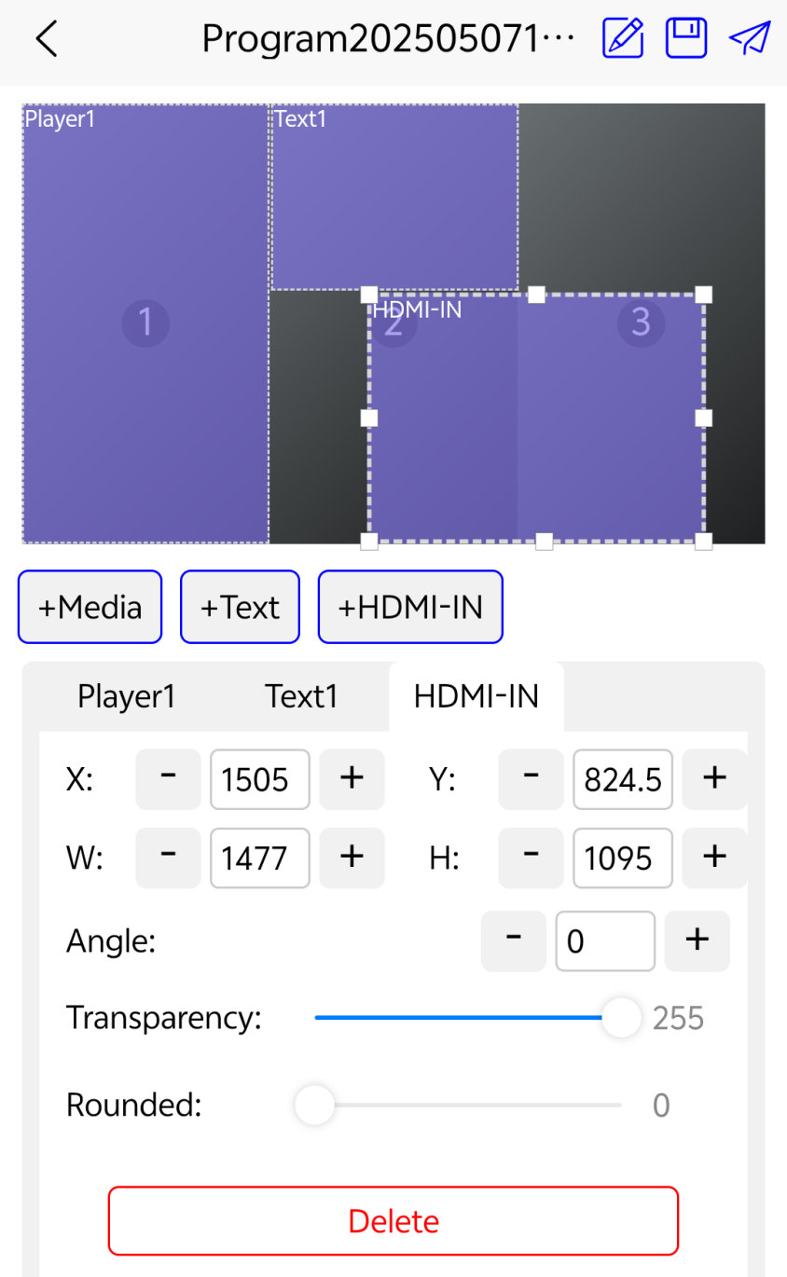
Figure 5-5 HDMI-IN window settings

  - Screen splicing and splitting operation guide
    - Debug interface
After adding a program, the operation interface will be displayed as shown in Figure 5-6.
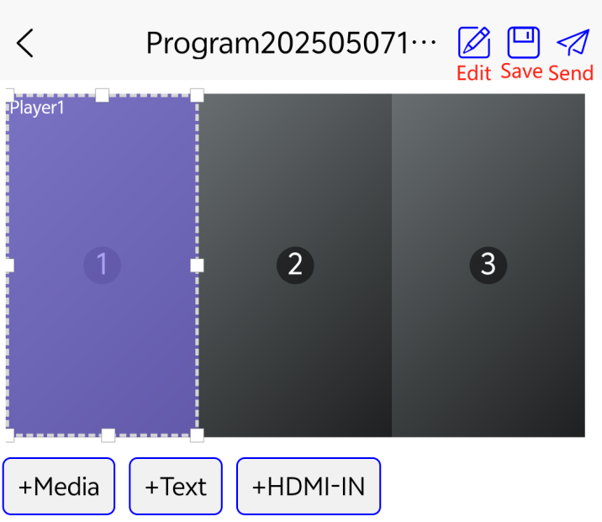
Figure 5-6 Debug interface
    - Screen settings
Click Edit in the upper right corner as shown in Figure 5-6 to enter the screen settings page, where you can edit the program name and adjust the screen angle and gap.
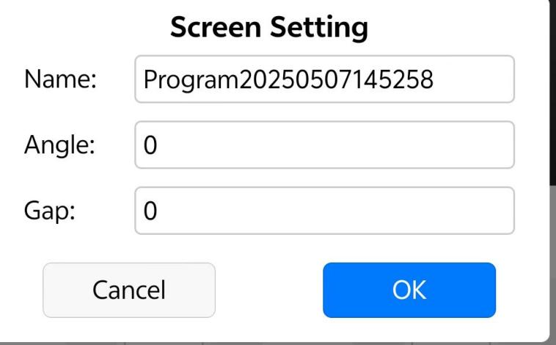
Figure 5-7 Screen settings
    - save
After completing the window design, you must click the Save button in the upper right corner as shown in Figure 5-6, otherwise it cannot be sent. Each time you modify the window content, you must click Save before sending.
    - Log in
After saving, click Send as shown in Figure 5-6, enter the program publishing page in Figure 5-8, and click Login (initial account: admin password: public)
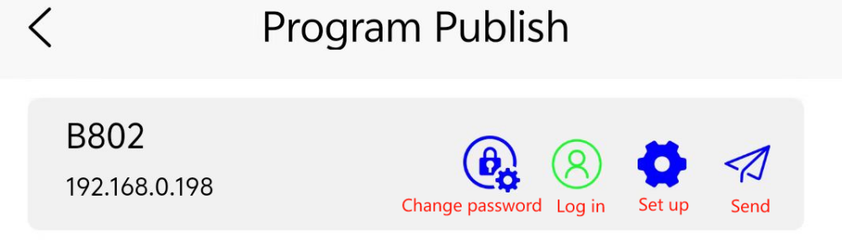
Figure 5-8 Program Release
    - Set up
If it is the first time to use, you can click the settings in Figure 5-8 to modify the device name to facilitate the next search. You can also view the device IP address, SN\version information, storage space, etc. as shown in Figure 5-9.
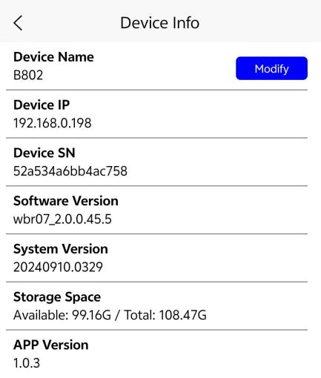
Figure 5-9 Device information
    - Send
After completing the above steps, click the Send button in the upper right corner.
- Maintenance and Security
This system has been strictly debugged before leaving the factory, but incorrect use may cause electric shock and fire. To ensure safety, extend the service life of this system, and give full play to the best performance of this system, please read the following regulations carefully before using the system and strictly abide by the safety precautions.
  - Precautions
- around the TV screen to ensure proper ventilation; do not cover the vents with items such as newspapers, tablecloths, and curtains that may obstruct ventilation.
- Do not place it outdoors and avoid direct sunlight, rain and wind.
- Before installing the wall mount, you must check the load-bearing reliability of the installation wall surface.
- When unplugging the power cord, do not just hold the cord.
- Do not place heat or naked flame sources, such as lighted candles or night-lights, on or near the unit.
- If the power cord is found to be damaged, do not continue to use it.
- To protect the environment, used batteries should be disposed of according to the recycling methods implemented in the area.
- Do not use in humid, high temperature or flammable environments .
- Children should use interactive features under adult supervision

  - Daily maintenance
- TV case and controller case with a soft dry cloth . If the case is very dirty, wipe it with a neutral detergent dissolved in water, and avoid touching the screen.
- Do not use thinners, gasoline, alcohol or other organic solvents to wipe the machine. When wiping the screen, be sure to use a dedicated LCD cleaning cloth (or a soft, lint-free cotton cloth) and spray it with an appropriate amount of deionized water to make the cleaning cloth slightly damp, then wipe it gently. When wiping, be sure to move gently, otherwise the screen will be easily scratched.
- Trouble shooting
Fault | Solution
Unable to turn on | Check whether the power supply is plugged into the interface;  Is the socket supplying power normally?
Unable to enter the PC debugging interface | Check whether the IP address is correct;  Are the computer and the screen splicing server in the same network domain?  Is the computer network connection normal?
Unable to enter the mobile debugging interface | Check whether the mobile phone and the screen splicing server are in the same network domain;
The stitching is not complete | Check whether the TV screen is connected to the controller in order;  Adjust the screen layout setting angle;
- Technical Support
Official website: http://www.veeluame.com/
Customer service hotline: 86-86933020
Contact Email: admin@veeluame.com
Warranty: The warranty period of the whole system is one year
Note: The specific parameters are subject to the physical label, and the right of interpretation for technical upgrades is reserved

Appendix: VeeControl controller interface diagram
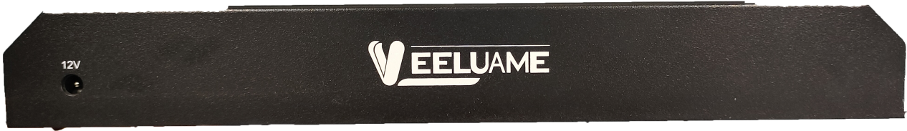
Figure 1: Front view of VeeControl
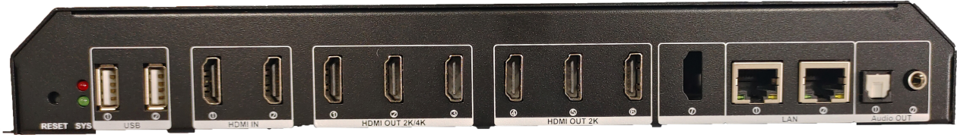
Figure 2: VeeControl rear interface diagram
Serial number | Interface Name | Interface Description
1 | Power | 12V power supply
2 | Audio out | Audio output: one 3.5mm , one optical fiber
3 | LAN | Gigabit network access
4 | HDMI OUT 2K | HDMI signal source output
5 | HDMI OUT 2K/4K | HDMI signal source output: support 2K or 4K resolution
6 | HDMI IN | HDMI signal input
7 | USB | Can connect USB flash drive
8 | SYS | The red LED is the power indicator; the green LED is the system working indicator. When the system is working normally, the red LED is always on and the green LED flashes frequently.
9 | RESET | System reset. Press and hold for about 10 seconds to restart the system. Note: This operation will clear all data, including the material in the device.

